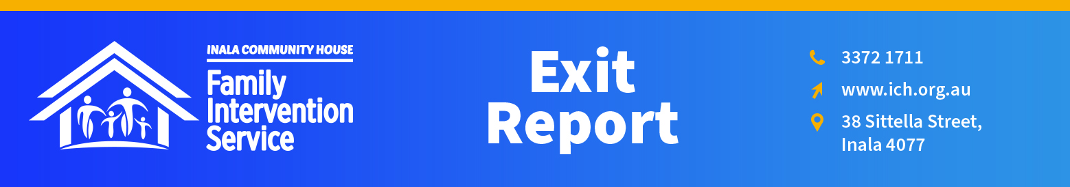

Client’s Full Name:
Date of Commencement: |  |  |  |  | Date of Exit:
Child Safety Officer: |  |  |  |  |  | CSSC:
Family Action Plan Date: |  |  |  | ICH FIS Worker:
Reason for FIS Closure
Lack of engagement by client/s |  |  |  |  |  |  |  | Yes ☐ No ☐
Goals have been met/mostly met |  |  |  |  |  |  |  | Yes ☐ No ☐
Other (If ‘Yes’, please specify below) |  |  |  |  |  |  |  | Yes ☐ No ☐
Previous Progress Reports Provided to Child Safety
Overall Assessment of Whether Goals Have Been Met
Child Developmental Outcomes |  |  | Goal/s:
Summary of progress towards goal statement over period of ICH FIS engagement
Goal Attainment |  |  | Not Met ☐ |  | Approaching ☐ |  |  |  |  | Met ☐
Emotional Availability, Attachments & Relationships |  |  | Goal/s:
Summary of progress towards goal statement over period of ICH FIS engagement
Goal Attainment |  |  | Not Met ☐ |  | Approaching ☐ |  |  |  |  | Met ☐
Parenting Values and Expectations |  |  | Goal/s:
Summary of progress towards goal statement over period of ICH FIS engagement
Goal Attainment |  |  | Not Met ☐ |  | Approaching ☐ |  |  |  |  | Met ☐
Parental Emotional Regulation & Problem Solving |  |  | Goal/s:
Summary of progress towards goal statement over period of ICH FIS engagement
Goal Attainment |  |  | Not Met ☐ |  | Approaching ☐ |  |  |  |  | Met ☐
Connection to Culture, Community and Family |  |  | Goal/s:
Summary of progress towards goal statement over period of ICH FIS engagement
Goal Attainment |  |  | Not Met ☐ |  | Approaching ☐ |  |  |  |  | Met ☐
Real World Problems |  |  | Goal/s:
Summary of progress towards goal statement over period of ICH FIS engagement
Goal Attainment |  |  | Not Met ☐ |  | Approaching ☐ |  |  |  |  | Met ☐
Engagement With Family
If not detailed above, outline dates of engagement/attempted engagement with family. Particularly relevant if closure is due to non-engagement.
Other Services Involved
Service |  |  |  |  | Service
Contact Person |  |  |  |  | Contact Person
Contact Details |  |  |  |  | Contact Details
Service |  |  |  |  | Service
Contact Person |  |  |  |  | Contact Person
Contact Details |  |  |  |  | Contact Details
Safety and Wellbeing Scale
10 corresponding with enough safety for FIS believing no further involvement by Child Safety is needed. 0 corresponding with limited or no safety within the family home and children not being able to reside safety in the home.
Initial Safety and Wellbeing Scale (completed at beginning of intervention)
1 | 2 | 3 | 4 | 5 | 6 |  | 7 | 8 |  | 9 | 10
☐ | ☐ | ☐ | ☐ | ☐ | ☐ |  | ☐ | ☐ |  | ☐ | ☐
Current Safety and Wellbeing Scale Assessment
1 | 2 | 3 | 4 | 5 | 6 |  | 7 | 8 |  | 9 | 10
☐ | ☐ | ☐ | ☐ | ☐ | ☐ |  | ☐ | ☐ |  | ☐ | ☐
Rationale
Overall Comments and Recommendations
(Engagement with FIS, recommendations about further work to occur, referrals made or recommended and an overall assessment of clients progress towards Goals, referencing Acts of Protection/Belonging and Client Strengths/Resources as well as Complicating factors).

Case Worker name, signature and date:
FIS Manager name, signature and date:

